Django Project
E-Classroom

Tools: -
- Virtual Studio
- Xampp and Command Prompt.
Code:
- Python
- HTML
- MySQL

Steps to create E-classroom Project: -

Step 1: - Install Virtual Studio.
Step 2: - Create a folder in C-drive.
Step 3: - Go to terminal and use command Prompt.

Step 4: - Install once virtual environment if you are doing project for the first time.
Syntax: -
pip install virtualenv

Step 5: - Create virtual environment.
Syntax:
Virtualenv environmentname
In my Project i.e.
Virtualenv env

Step 6: - Activate Virtual Environment.
Syntax: -
env\Scripts\activate
Deactivate Virtual Environment
Syntax: -
env\Scripts\deactivate
Step 7: - Install Django in virtual Environment.
Syntax: -
pip install Django
Step 8: - Create Django Project
Syntax: -
django-admin startproject projectname
In my Project, i.e.
django-admin startproject learningProject

Step 9: - Create Application.
Syntax: -
python manage.py startapp appname
In my Project, i.e.
python manage.py startapp learningapp

Step 10: - Running Server.
Syntax: -
python manage.py runserver
To stop server.
Ctrl + C

- File Content: -
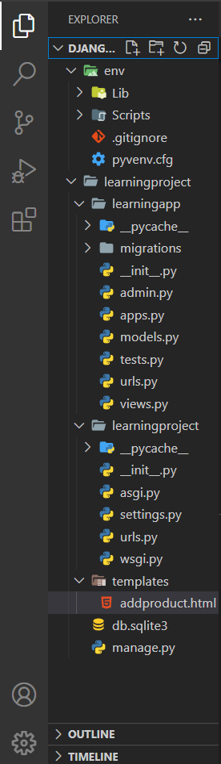

Step 11: -
- Create urls.py file in application folder.
- Register urls.py file from application folder into urls.py file in project folder. So that Django server recognised all urls define in urls.py file in application folder.
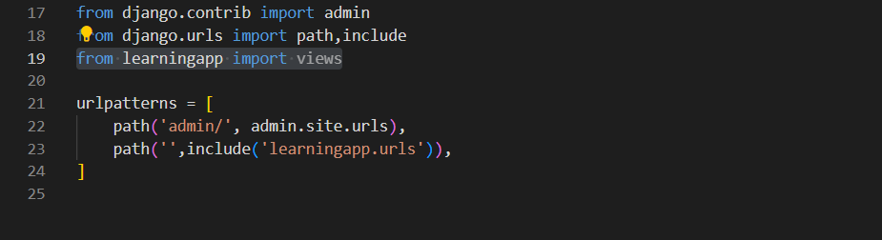
Step 12: -
- Create templates folder in project folder.
- Go to settings.py in project folder to make some changes.
- Write import os on line no.14
- Write application name in INSTALLED_APP on line no.41.
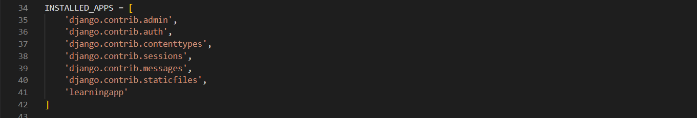
- Add one code on line no.59.
os.path.join(BASE_DIR,’templates’)
BASE_DIR: - path which is create in C-drive
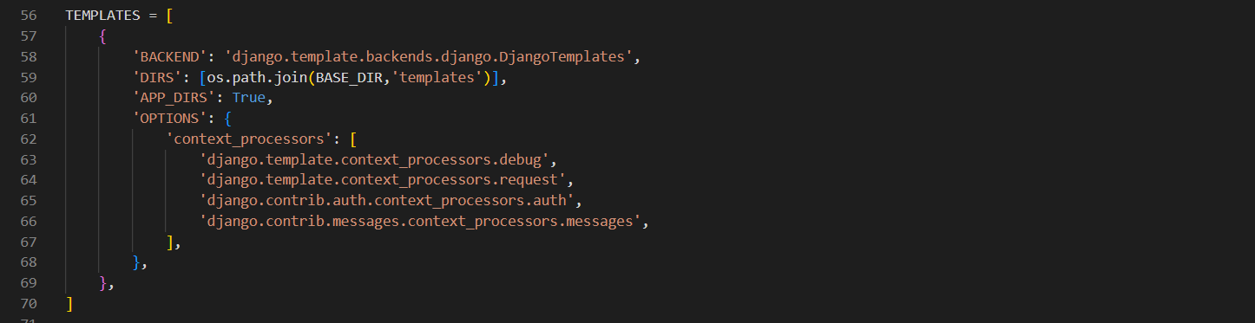

Step 13: -
- Create a database in DBMS
Create database learn1234.

- Make changes in setting.py
Change the default sqlite3 to mysql
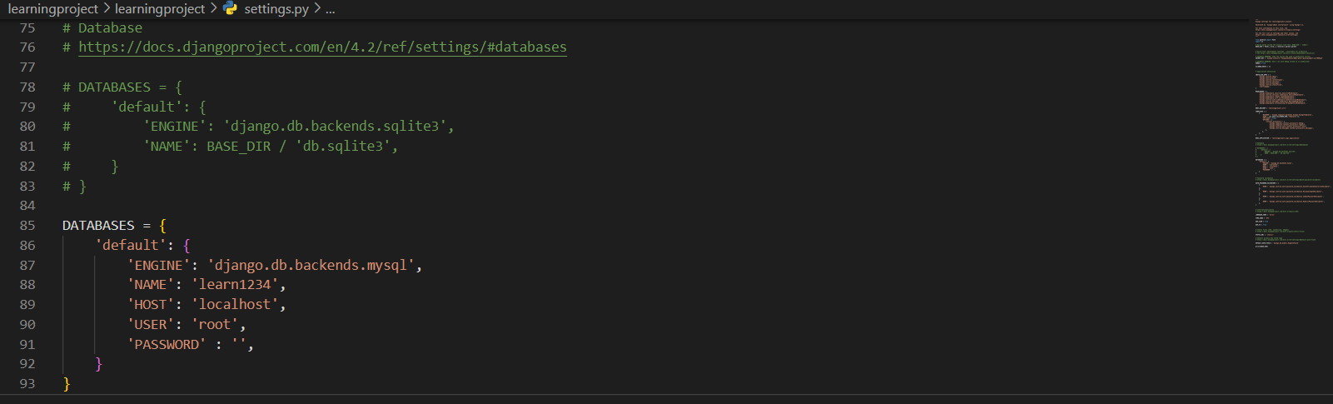
- Getting and error then do install mysqlclient.
- Stop the server.
- pip install mysqlclient

Step 14: -
- from models.py import models
from Django.db import models

- creating table/model in Django.
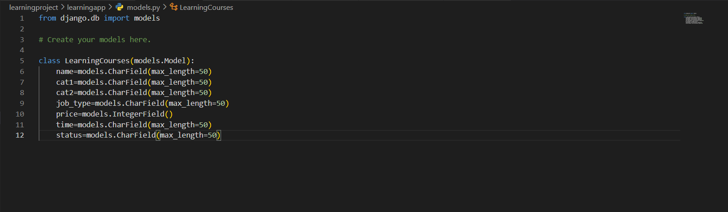
- After Creating table/model in Django make migrations.
python manage.py makemigrations

- Run migration.
python manage.py migrate
Note: - It will migrate all the pending application.

Step 15: -
- Create addproduct.html, dashboard.html and edit.html inside templates folder.

- addproduct.html: -
- Views.py
- Urls.py
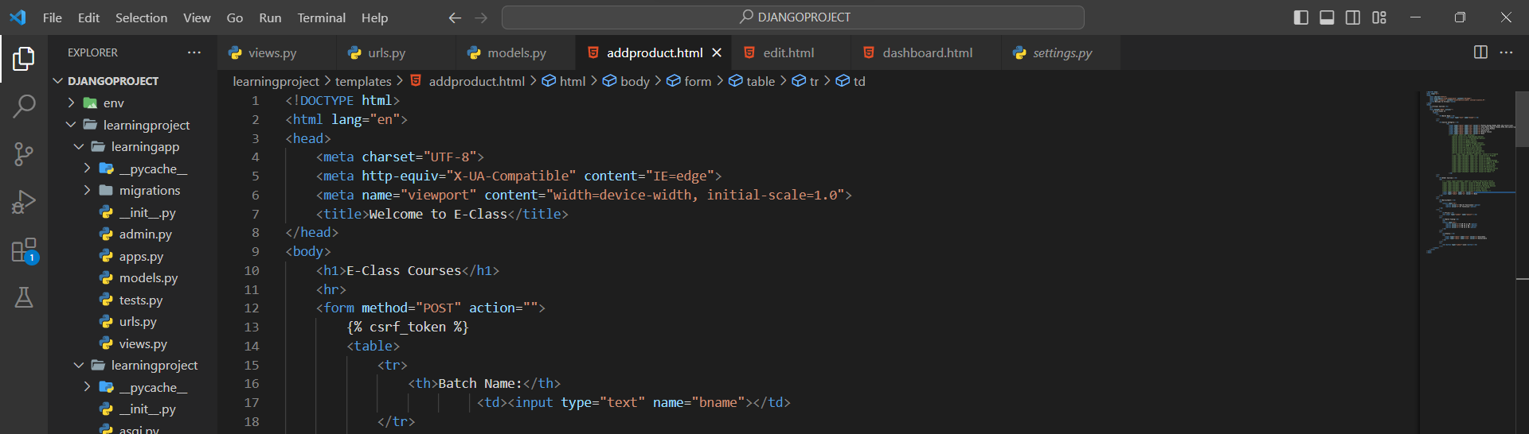
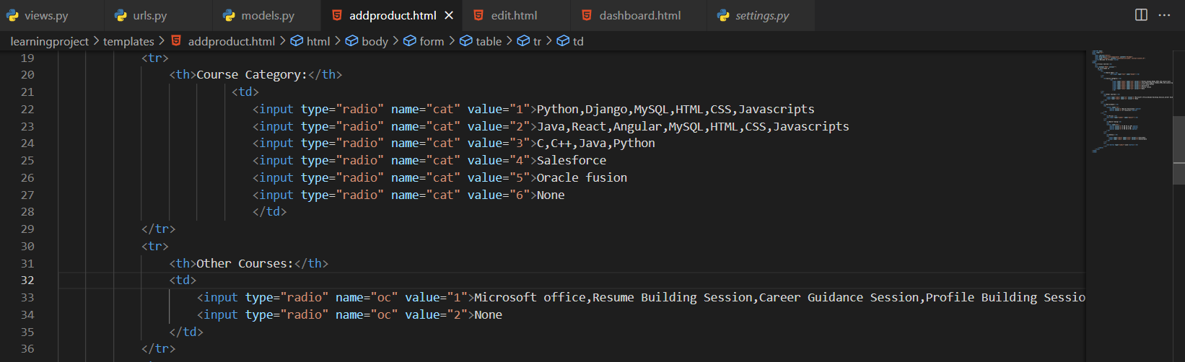
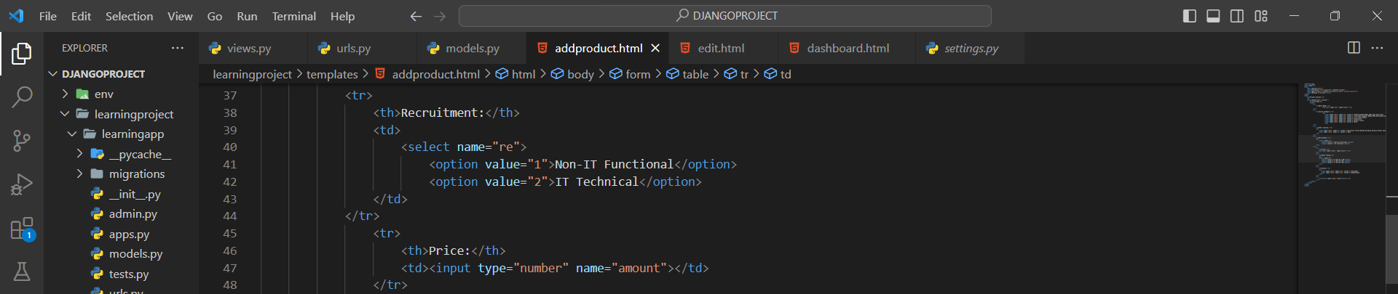
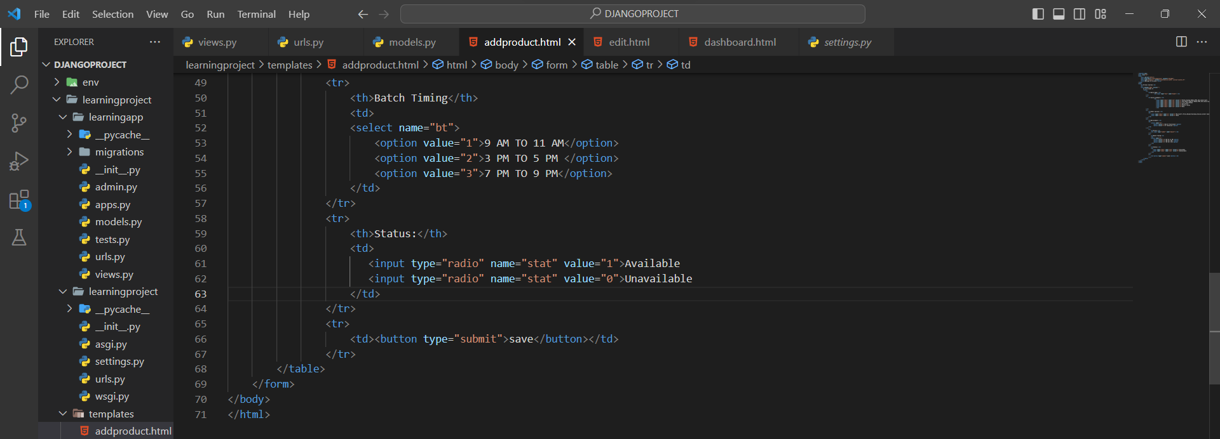
views.py for addproduct: -
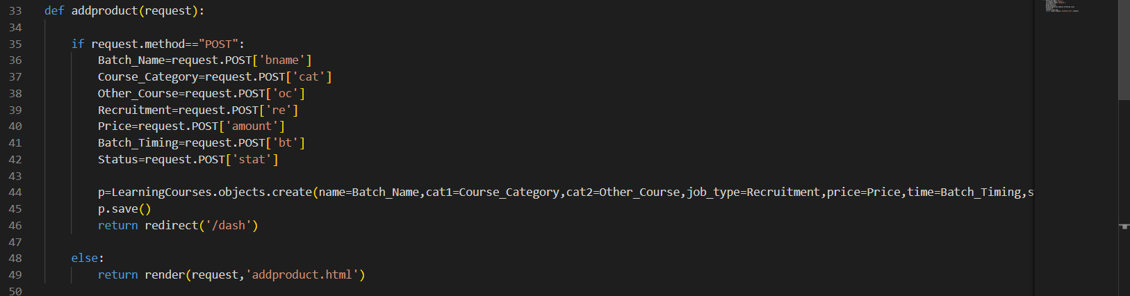
urls.py for addproduct: -

- dashboard.html: -
In dashboard also added edit, delete, filter, sort and multifilter.
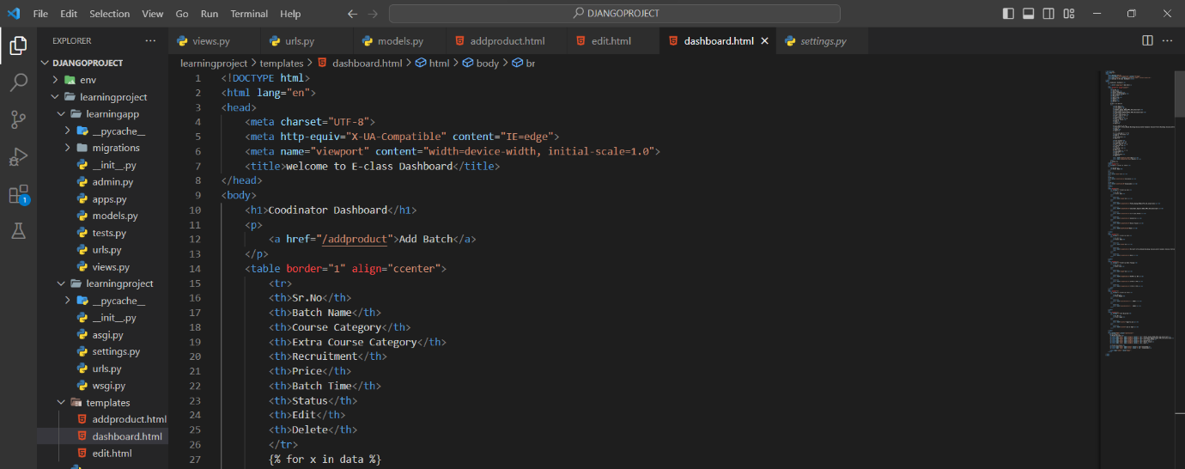
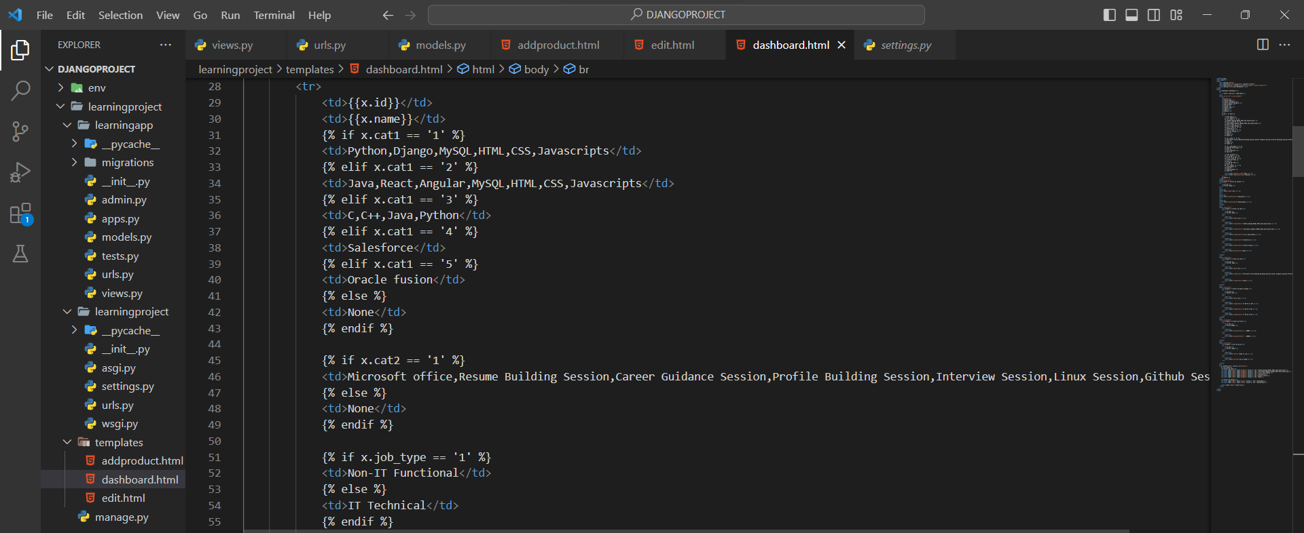
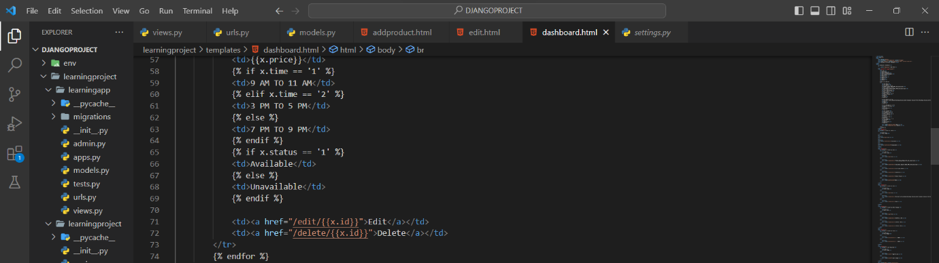

views.py for dashboard: -
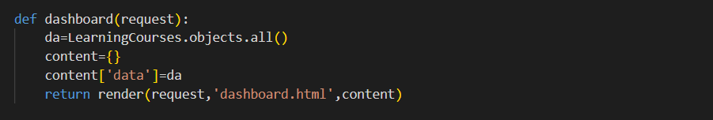
urls.py for dashboard: -

- Edit: -
First create edit.html in the template folder copy and past addproduct html code inside edit.html file.
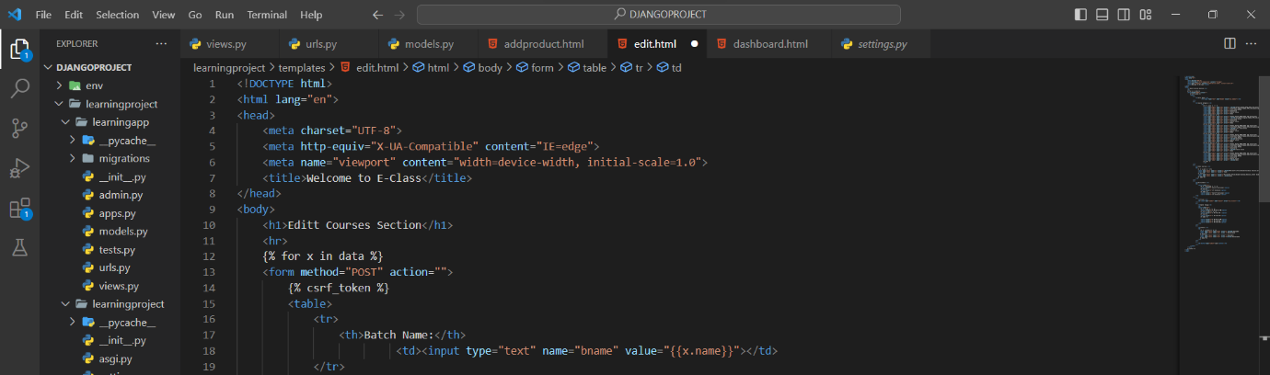
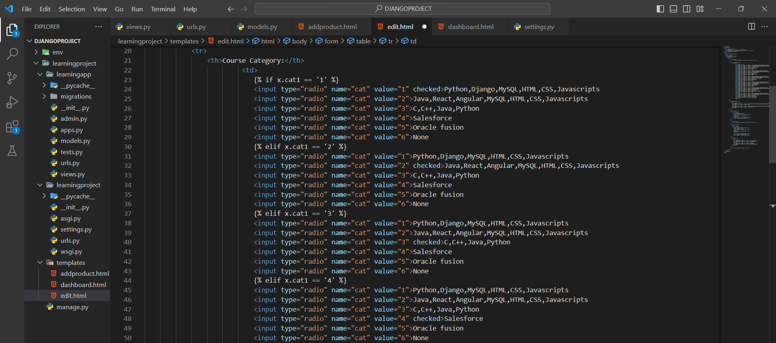
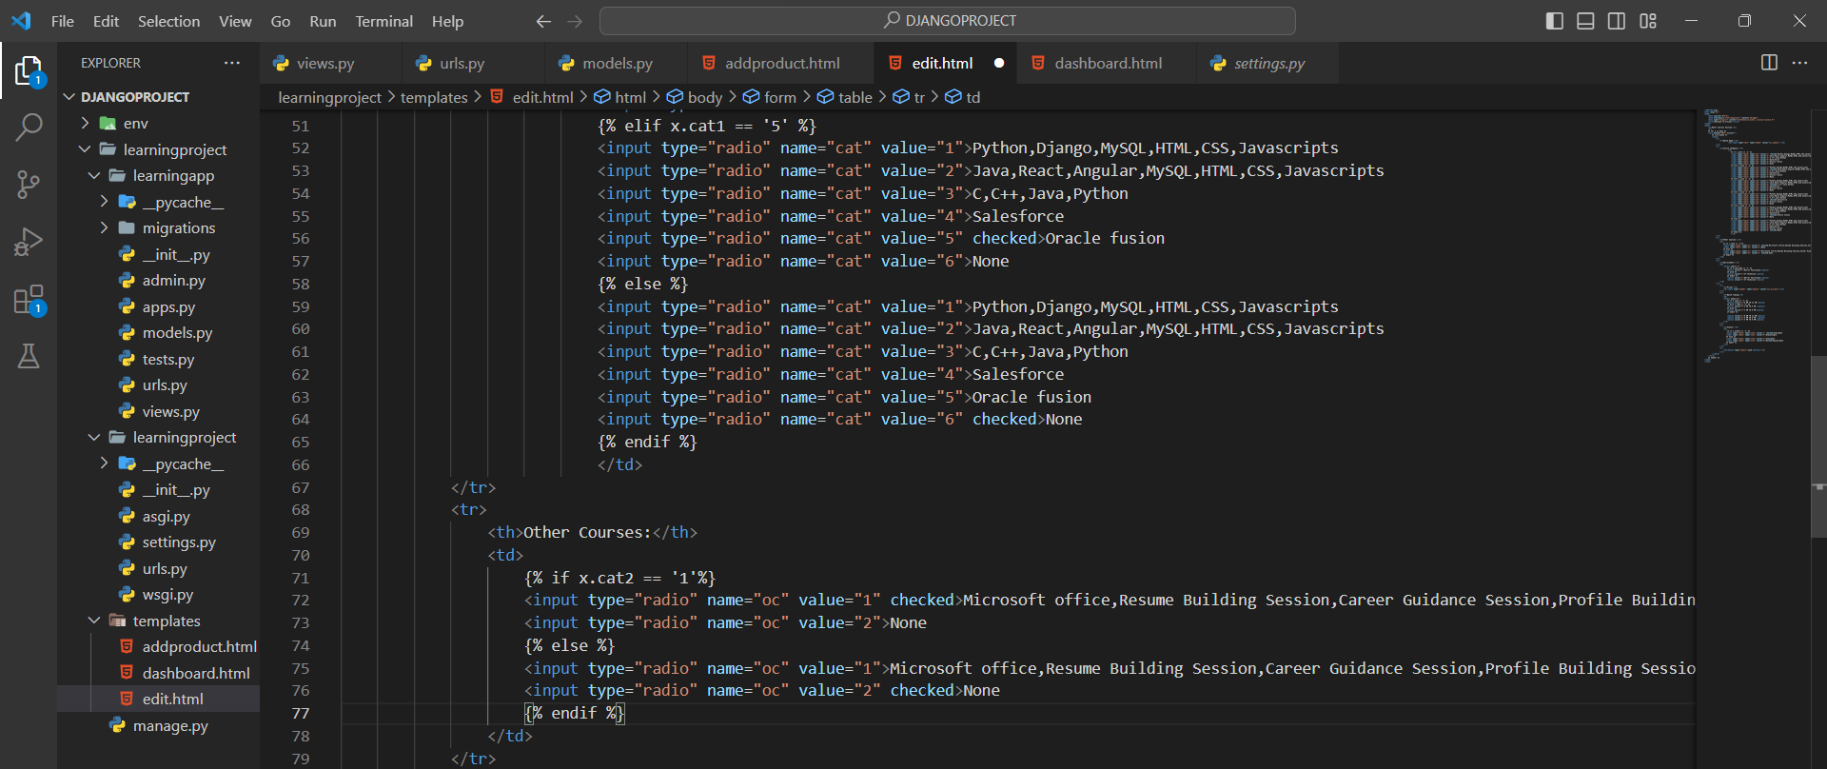
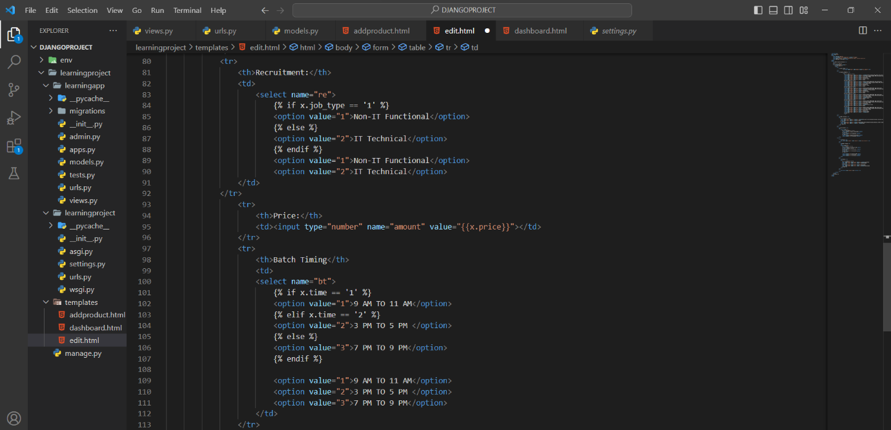
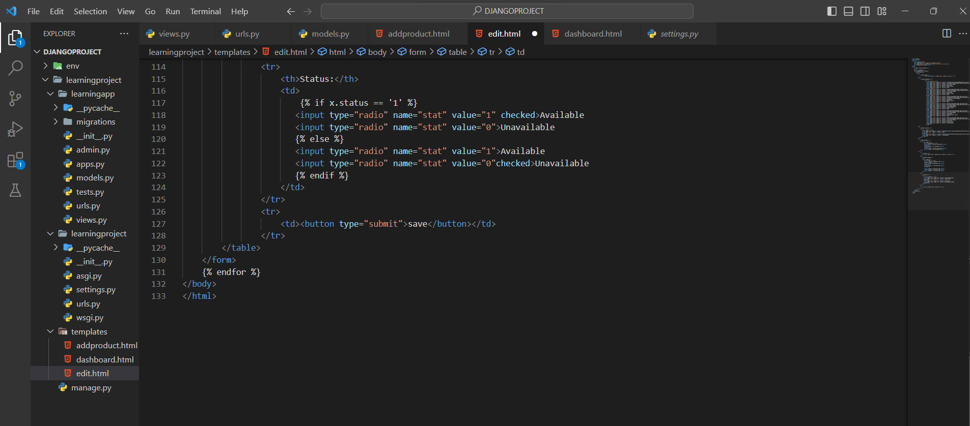

views.py for edit: -
Syntax: -
p=LearningCourses.objects.filter(id=rid)
p.update(name=Batch_Name,cat1=Course_Category,cat2=Other_Course,job_type=Recruitment,price=Price,time=Batch_Timing,status=Status)

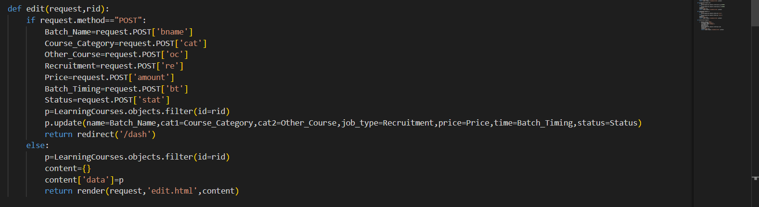
urls.py for edit: -

- Delete: -
Do not create any html file for delete.
views.py for delete: -
Syntax: -
p=LearningCourses.objects.filter(id=rid)
p.delete()

urls.py for delete: -

- Filters for dashboard: -
Do not create html file for filter. Assign it to dashboard.html.
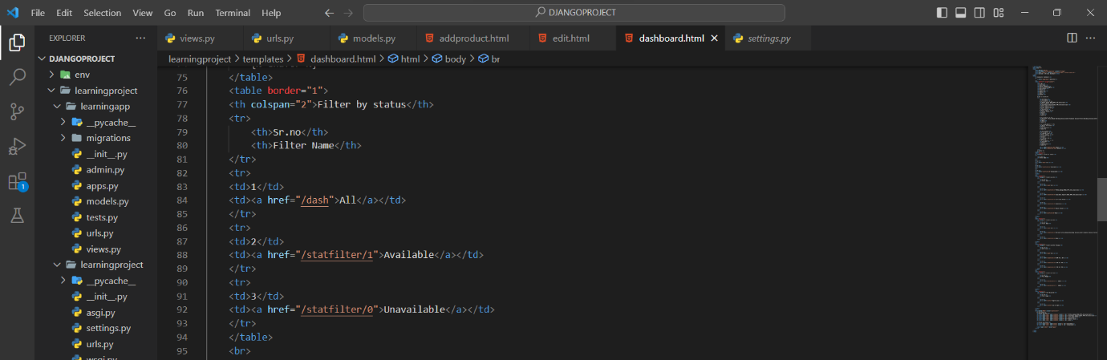
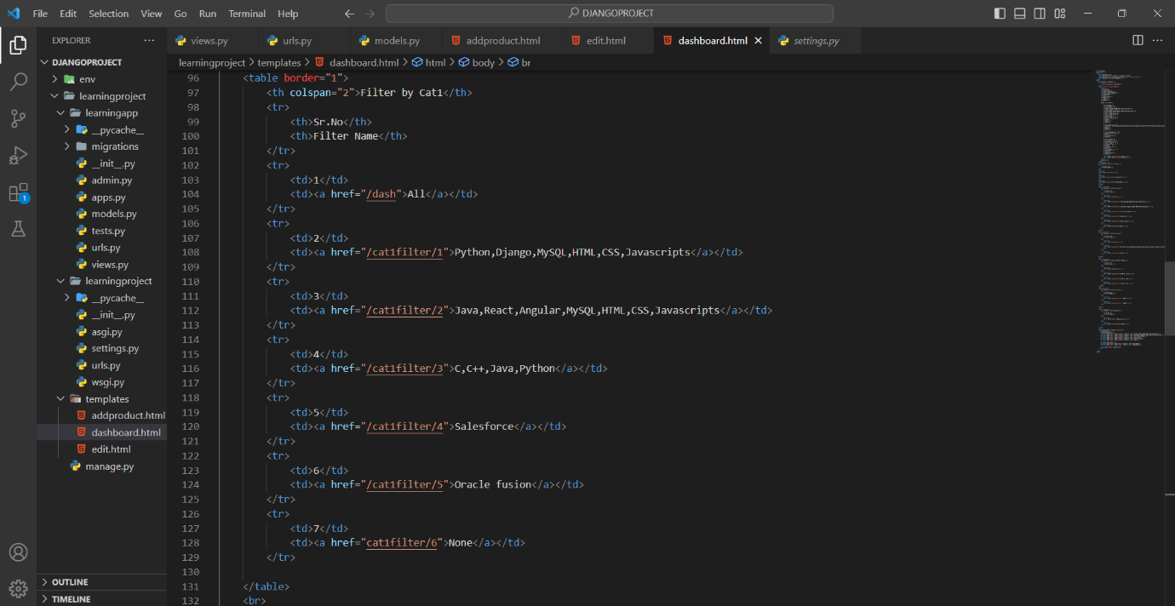
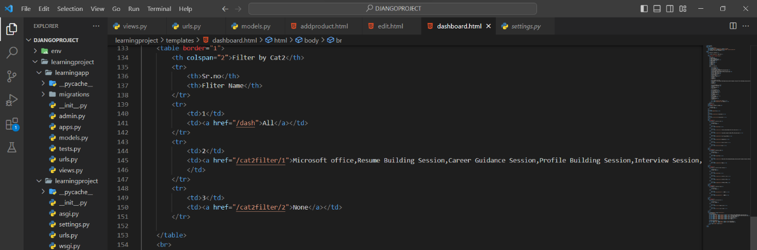
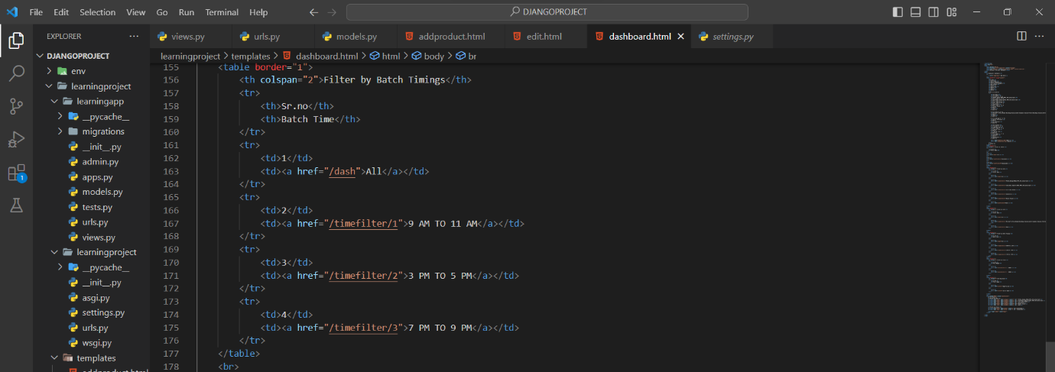
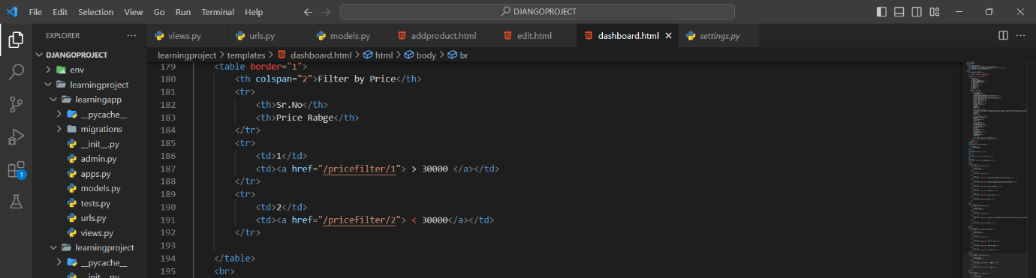

views.py for Filter: -
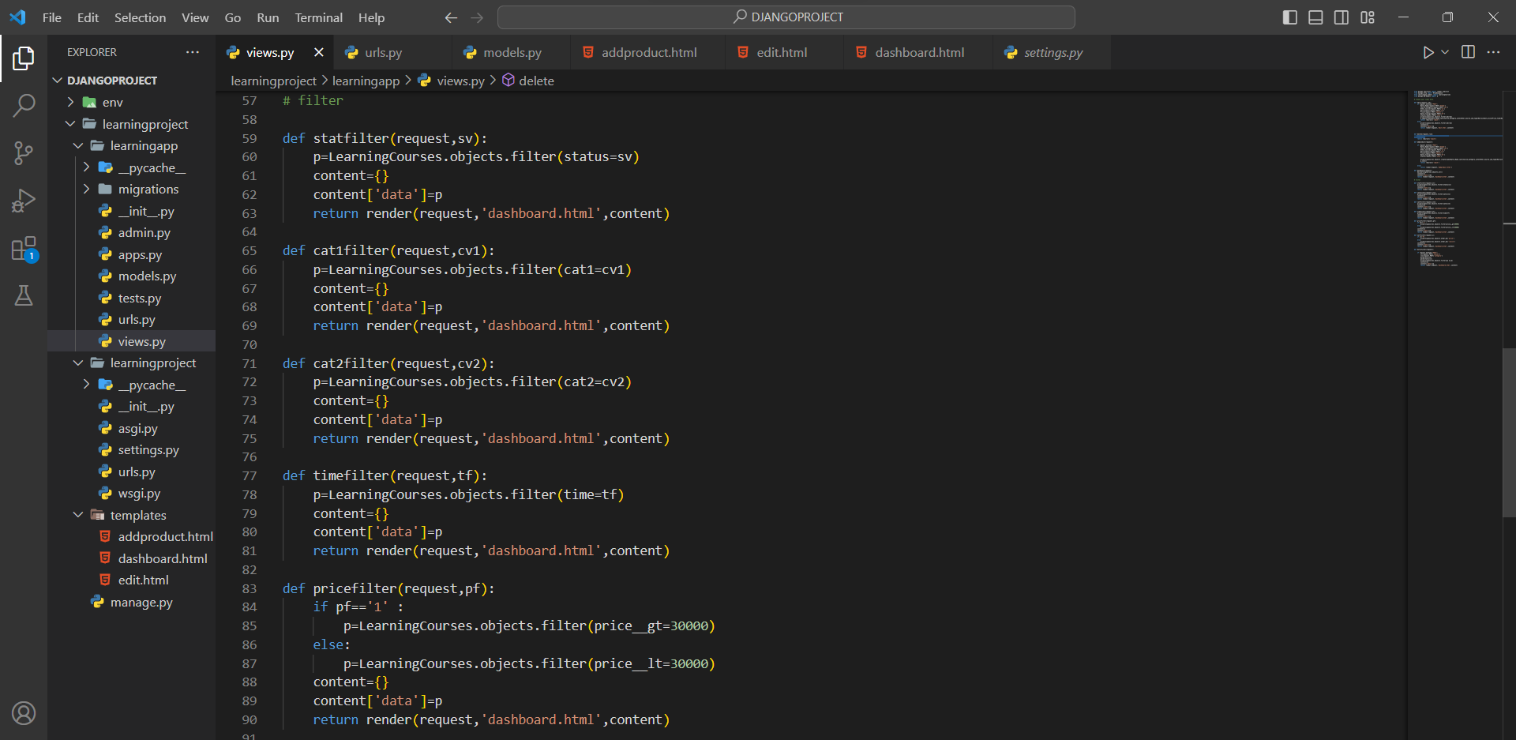
url.py for Filter: -
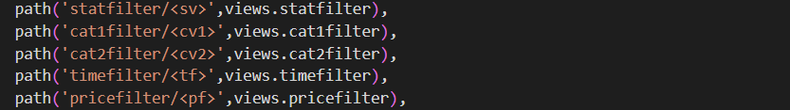

- Sort for Dashboard: -
Do not create html file for filter. Assign it to dashboard.html

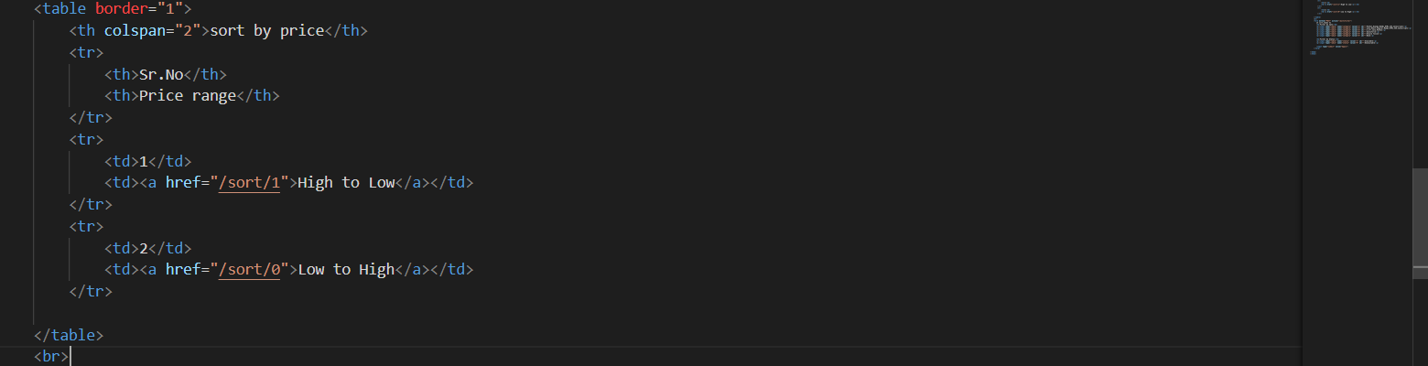
views.py for Sort: -
Syntax: -
p=LearningCourses.objects.order_by('price/-price')
where,
price is ascending order.
-price is descending order.
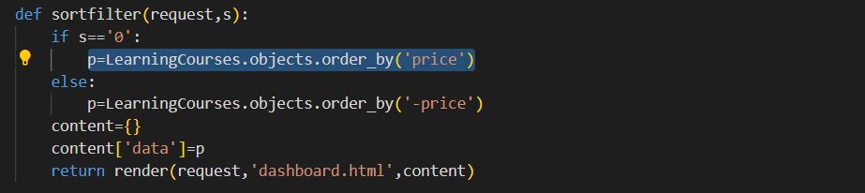

urls.py for sort: -

- Multifilter for dashboard: -
Do not create html file for filter. Assign it to dashboard.html
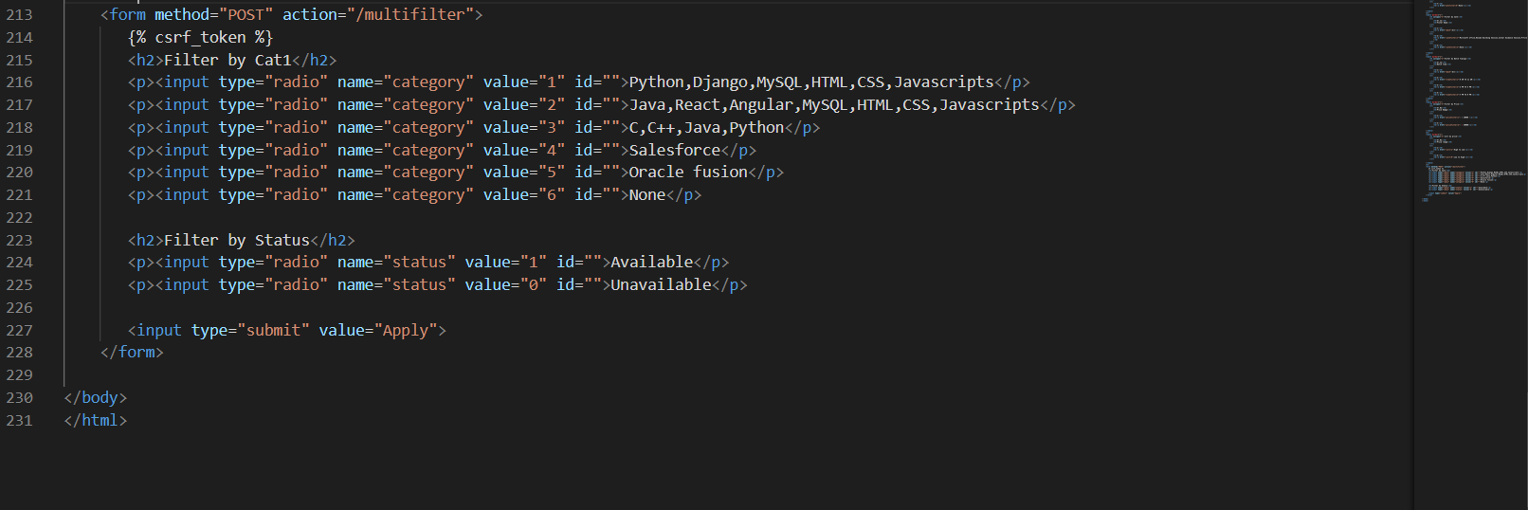
Views.py for multifilter: -
In views, import Q from django.db.models
Syntax: -
from django.db.models import Q

q1 = Q(condition 1)
q2 = Q(condition 2)
queryset = Modelname.objects.filter(q1 & q2)
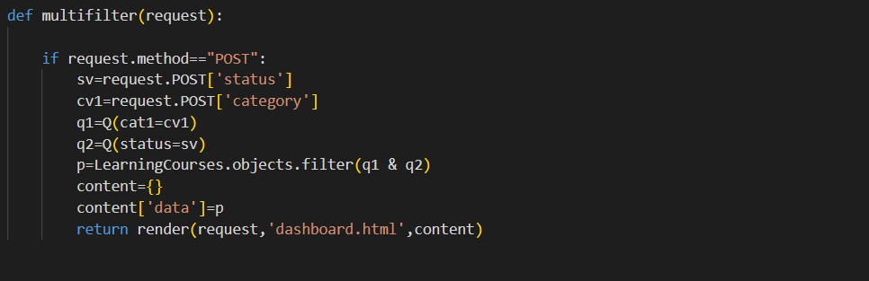

urls.py for multifilter: -
